OLYMPUS

Directions For Use
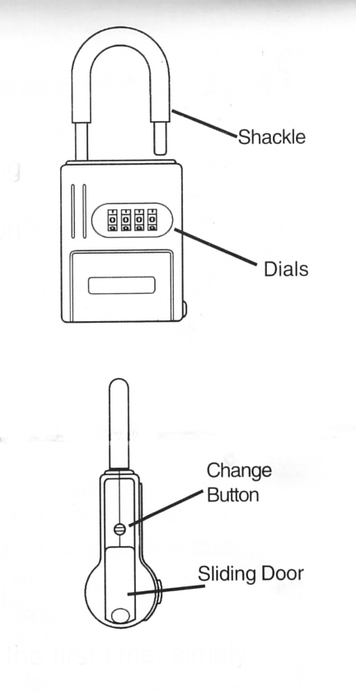
The Olympus operates on a patented system of two groups of combinations. One combination opens the shackle (factory setting on 0-0-0-0) and the second combination opens the sliding key storage door (factory setting on 3-3-3-3).

To set your combination at any time, follow the instructions below.

- Set dials on the shackle opening combination (factory setting on 0-0-0-0) and open the shackle.
- Use a coin or paper clip to turn the change button 90 degrees (1/4 turn) clock-wise. Never force the change button. If it is difficult to turn, make sure the numbers are lined up and that you have the correct combination.
- Set the combination to the desired shackle combination.
- Return the change button to the original position by turning counter-clockwise 90 degrees (1/4 turn).
- The sliding door combination is automatically set when the new shackle combination is set. Follow the chart below to find the new combination for the sliding door

NOTES: Some locks are stiff being new. If the lock will not open the first time

Shackle & door opening number chart
Shackle | 0 | 1 | 2 | 3 | 4 | 5 | 6 | 7 | 8 | 9
Door | 3 | 4 | 5 | 6 | 7 | 8 | 9 | 0 | 1 | 2

